- ReactJS-HOL

App.js

import React, { useState } from "react";
import ListofPlayers from "./components/ListofPlayers";
import Scorebelow70 from "./components/Scorebelow70";
import OddPlayers from "./components/OddPlayers";
import EvenPlayers from "./components/EvenPlayers";
import ListofIndianPlayers from "./components/ListofIndianPlayers";

// Example placeholder data (replace with yours)
const players = [
{ name: "Mr. Jack", score: 50 },
{ name: "Mr. Michael", score: 70 },
{ name: "Mr. John", score: 40 },
{ name: "Mr. Ann", score: 61 },
{ name: "Mr. Elisabeth", score: 61 },
{ name: "Mr. Sachin", score: 95 },
{ name: "Mr. Dhoni", score: 100 },
{ name: "Mr. Virat", score: 84 },
{ name: "Mr. Jadeja", score: 64 },
{ name: "Mr. Raina", score: 75 },
{ name: "Mr. Rohit", score: 80 },
];

const IndianTeam = [
{ id: 1, name: "Sachin" },
{ id: 2, name: "Dhoni" },
{ id: 3, name: "Virat" },
{ id: 4, name: "Rohit" },
{ id: 5, name: "Yuvaraj" },
{ id: 6, name: "Raina" }
];

const IndianPlayers = [
"Mr. First Player",
"Mr. Second Player",
"Mr. Third Player",
"Mr. Fourth Player",
"Mr. Fifth Player",
"Mr. Sixth Player"
];

function App() {
const [flag, setFlag] = useState(true);

return (
<div className="App">
<button onClick={() => setFlag(prev => !prev)}>
Toggle Flag (Currently {flag ? "True" : "False"})
</button>
<hr />
{flag === true ? (
<div>
<h1>List of Players</h1>
<ListofPlayers players={players} />
<hr />
<h1>List of Players having Scores Less than 70</h1>
<Scorebelow70 players={players} />
</div>
) : (
<div>
<h1>Indian Team</h1>
<h1>Odd Players</h1>
<OddPlayers IndianTeam={IndianTeam} />
<hr />
<h1>Even Players</h1>
<EvenPlayers IndianTeam={IndianTeam} />
<hr />
<h1>List of Indian Players Merged:</h1>
<ListofIndianPlayers IndianPlayers={IndianPlayers} />
</div>
)}
</div>
);
}

export default App;

ListofPlayers.js

const ListofPlayers = ({ players }) => (
<ul>
{players.map((p, idx) => (
<li key={idx}>{p.name} {p.score}</li>
))}
</ul>
);

export default ListofPlayers;

Scorebelow70.js
const Scorebelow70 = ({ players }) => (
<ul>
{players.filter(p => p.score < 70).map((p, idx) => (
<li key={idx}>{p.name} {p.score}</li>
))}
</ul>
);

export default Scorebelow70;

OddPlayers.js
const OddPlayers = ({ IndianTeam }) => (
<ul>
{IndianTeam.filter((_, idx) => idx % 2 === 0).map((player, idx) => (
<li key={player.id}>
{`${["First", "Third", "Fifth"][idx]} : ${player.name}${player.id}`}
</li>
))}
</ul>
);

export default OddPlayers;

EvenPlayers.js
const EvenPlayers = ({ IndianTeam }) => (
<ul>
{IndianTeam.filter((_, idx) => idx % 2 === 1).map((player, idx) => (
<li key={player.id}>
{`${["Second", "Fourth", "Sixth"][idx]} : ${player.name}${player.id}`}
</li>
))}
</ul>
);

export default EvenPlayers;

ListofIndianPlayers.js

const ListofIndianPlayers = ({ IndianPlayers }) => (
<ul>
{IndianPlayers.map((name, idx) => (
<li key={idx}>{name}</li>
))}
</ul>
);

export default ListofIndianPlayers;

WHEN FALG IS FALSE
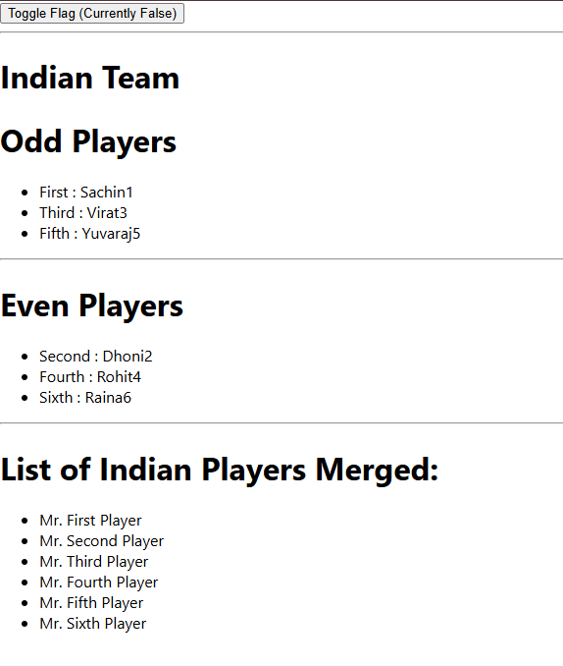

WHEN FLAG IS TRUE
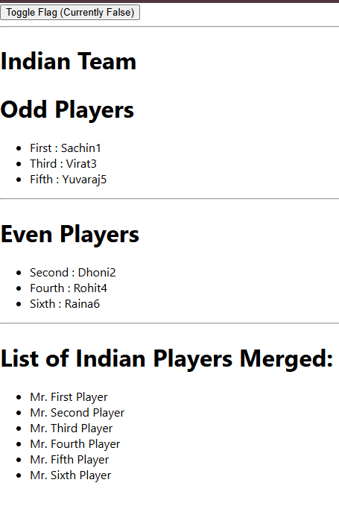

- ReactJS-HOL

App.js
import React from "react";

// Sample images. You should use URLs or import images from assets for a real app.
const officeImage = "https://images.unsplash.com/photo-1464983953574-0892a716854b?auto=format&fit=crop&w=400&q=80";

// List of office space objects
const officeList = [
{ Name: "DBS", Rent: 50000, Address: "Chennai" },
{ Name: "CoworkYou", Rent: 70000, Address: "Bangalore" },
{ Name: "Spaces365", Rent: 45000, Address: "Pune" },
{ Name: "Regus", Rent: 85000, Address: "Mumbai" }
];

// CSS styles for headings and rent colors
const rentStyles = {
textRed: { color: "red", fontWeight: "bold" },
textGreen: { color: "green", fontWeight: "bold" }
};

function App() {
return (
<div style={{padding: "30px"}}>
{/* Heading */}
<h1 style={{ fontWeight: "bold" }}>Office Space, at Affordable Range</h1>

{/* Image attribute */}
<img src={officeImage} width="25%" height="25%" alt="Office Space" style={{ margin: "20px 0" }} />

{/* Loop through officeList */}
{officeList.map((item, idx) => (
<div key={idx} style={{ marginBottom: 25 }}>
<h2>Name: {item.Name}</h2>
{/* Rent displayed in color based on value */}
<h3 style={item.Rent <= 60000 ? rentStyles.textRed : rentStyles.textGreen}>
Rent: Rs. {item.Rent}
</h3>
<h3>Address: {item.Address}</h3>
</div>
))}
</div>
);
}

export default App;

OUTPUT

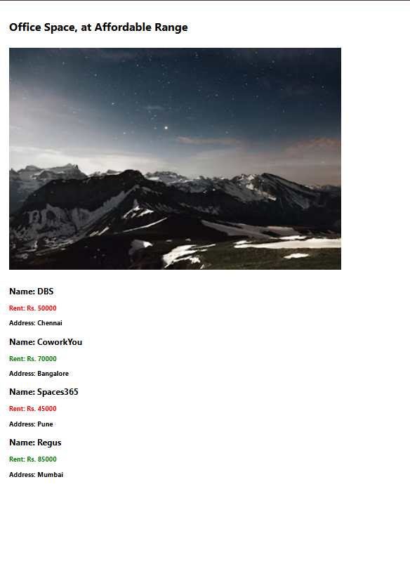

- ReactJS-HOL

App.js
import React, { useState } from "react";
import CurrencyConvertor from "./CurrencyConvertor";

function App() {
// Counter state
const [count, setCount] = useState(0);

// 1a. Method to increment
const increment = () => {
setCount(prevCount => prevCount + 1);
};

// 1b. Say hello with a static message
const sayHello = () => {
alert("Hello! This is your static message.");
};

// 1. Handler to call both increment and sayHello
const handleIncrease = () => {
increment();
sayHello();
};

// Decrement counter
const handleDecrease = () => {
setCount(prevCount => prevCount - 1);
};

// 2. "Say Welcome" button handler with argument
const sayCustomMessage = msg => {
alert(msg);
};

// 3. Synthetic event button
const onPressButton = () => {
alert("I was clicked");
};

return (
<div style={{ padding: 32 }}>
<h1>Event Examples App</h1>

{/* Counter with Increment/Decrement */}
<h2>Counter: {count}</h2>
<button onClick={handleIncrease}>Increment</button>{" "}
<button onClick={handleDecrease}>Decrement</button>

<br /><br />

{/* Say Welcome button with argument */}
<button onClick={() => sayCustomMessage("welcome")}>Say Welcome</button>

<br /><br />

{/* Synthetic onPress event */}
<button onClick={onPressButton}>OnPress</button>

<br /><br />

{/* Currency Converter */}
<CurrencyConvertor />
</div>
);
}

export default App;

CurrencyConvertor.js

import React, { useState } from "react";

const CONVERSION_RATE = 0.011; // Approximate Euro value for 1 INR

function CurrencyConvertor() {
const [rupees, setRupees] = useState("");
const [euro, setEuro] = useState("");

// Handles form submission and conversion
const handleSubmit = e => {
e.preventDefault();
if (rupees === "" || isNaN(+rupees)) {
setEuro("Invalid input");
return;
}
const euroValue = (+rupees * CONVERSION_RATE).toFixed(2);
setEuro(euroValue);
};

// Optionally handle input change
const handleChange = e => {
setRupees(e.target.value);
setEuro("");
};

return (
<div style={{ marginTop: 40 }}>
<h2>Currency Converter (INR to Euro)</h2>
<form onSubmit={handleSubmit}>
<input
type="text"
value={rupees}
onChange={handleChange}
placeholder="Enter amount in Rupees"
/>
<button type="submit">Convert</button>
</form>
{euro !== "" && (
<div style={{ marginTop: 16 }}>
<strong>Euro: </strong>
{euro}
</div>
)}
</div>
);
}

export default CurrencyConvertor;

OUTPUT
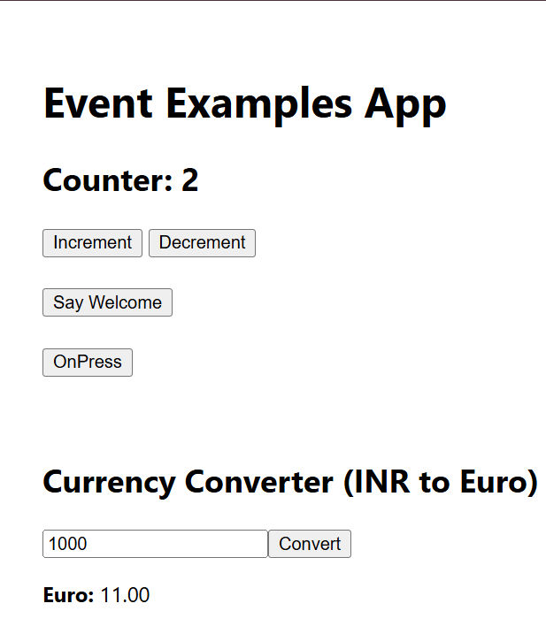
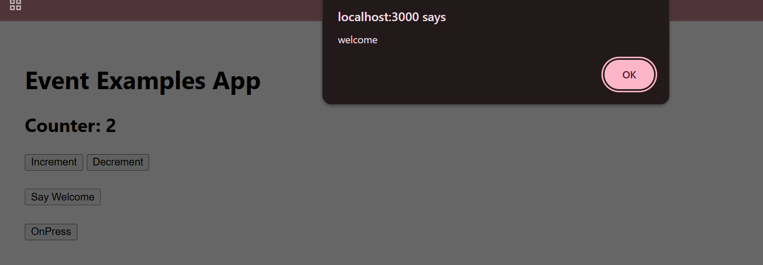

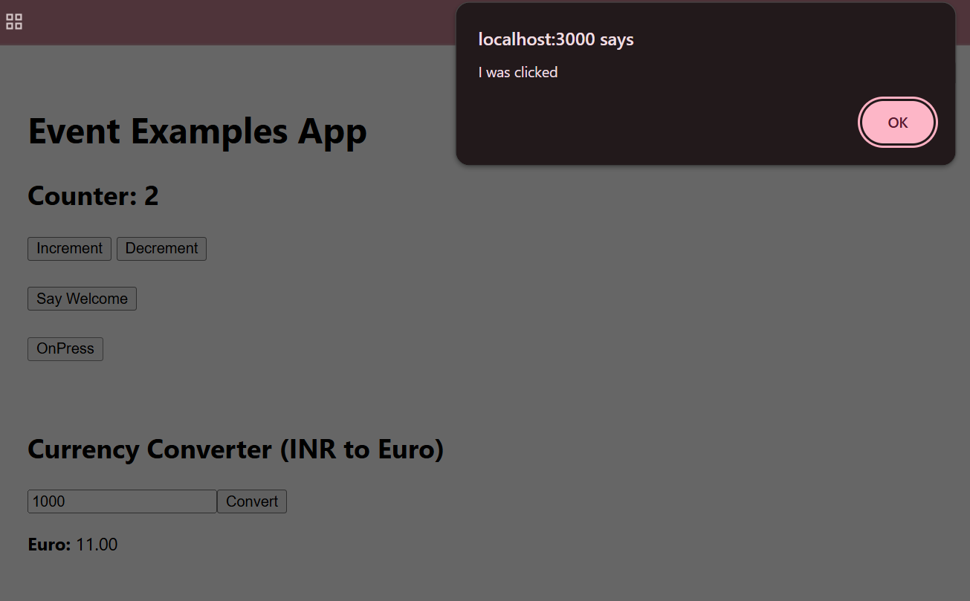

- ReactJS-HOL

App.js
import React, { useState } from "react";

// Reusable Login and Logout Button Components
function LoginButton({ onClick }) {
return <button onClick={onClick}>Login</button>;
}

function LogoutButton({ onClick }) {
return <button onClick={onClick}>Logout</button>;
}

// Simple list of flight details
const flights = [
{
id: 1,
from: "New Delhi",
to: "Mumbai",
date: "2025-04-15",
seats: 30,
price: 9500,
},
{
id: 2,
from: "Chennai",
to: "Bengaluru",
date: "2025-04-16",
seats: 15,
price: 7500,
},
{
id: 3,
from: "Kolkata",
to: "Hyderabad",
date: "2025-04-17",
seats: 20,
price: 8000,
},
];

// Flight List — displays for all users
function FlightList({ canBook }) {
return (
<div>
<h2>Available Flights</h2>
<table border="1" cellPadding={8}>
<thead>
<tr>
<th>Flight</th>
<th>Date</th>
<th>Seats</th>
<th>Price</th>
{canBook && <th>Book Ticket</th>}
</tr>
</thead>
<tbody>
{flights.map(flight => (
<tr key={flight.id}>
<td>{flight.from} → {flight.to}</td>
<td>{flight.date}</td>
<td>{flight.seats}</td>
<td>₹{flight.price}</td>
{canBook && (
<td>
<button onClick={() => alert(`Ticket booked for ${flight.from} to ${flight.to}!`)}>
Book
</button>
</td>
)}
</tr>
))}
</tbody>
</table>
</div>
);
}

// Greeting Components
function UserPage({ onLogout }) {
return (
<div>
<h1>Welcome back</h1>
<LogoutButton onClick={onLogout} />
<FlightList canBook={true} />
</div>
);
}

function GuestPage({ onLogin }) {
return (
<div>
<h1>Please sign up.</h1>
<LoginButton onClick={onLogin} />
<FlightList canBook={false} />
</div>
);
}

// Main App Component
function App() {
const [isLoggedIn, setIsLoggedIn] = useState(false);

const handleLogin = () => setIsLoggedIn(true);
const handleLogout = () => setIsLoggedIn(false);

return (
<div style={{ padding: '40px', fontFamily: 'Arial' }}>
{isLoggedIn ? (
<UserPage onLogout={handleLogout} />
) : (
<GuestPage onLogin={handleLogin} />
)}
</div>
);
}

export default App;

OUTPUT
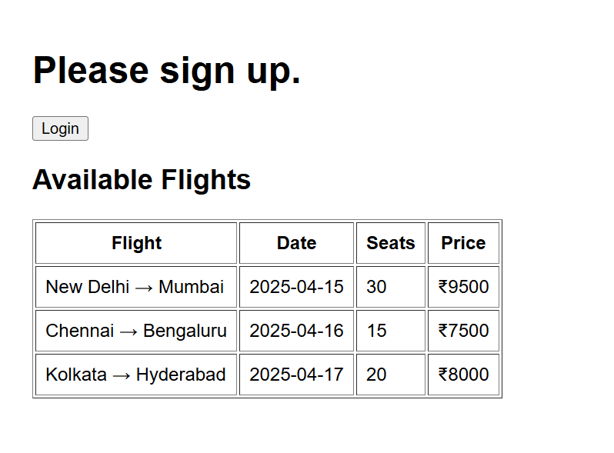

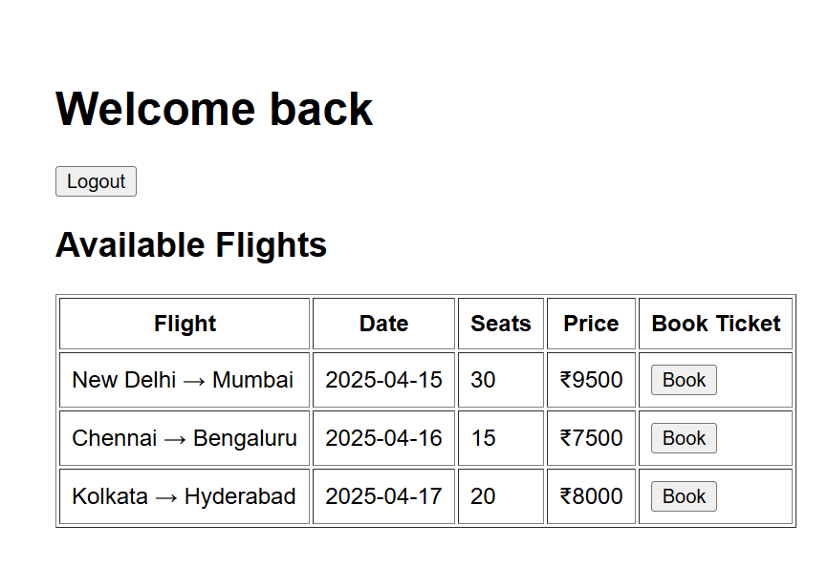

- ReactJS-HOL

BookDetails.js

import React from "react";

function BookDetails({ books, show }) {
// Conditional Rendering: Short-circuit &&, if-else block, ternary
if (!show) return null; // Method 1: return null (don’t render at all)

return (
<div>
<h2>Book Details</h2>
{/* Method 2: Ternary operator for content or fallback */}
{books && books.length > 0 ? (
<ul>
{/* Method 3: Element Variable */}
{books.map((book, idx) => (
<li key={book.id}>
{book.bname} – <span style={{color:"grey"}}>₹{book.price}</span>
</li>
))}
</ul>
) : (
<span>No books found!</span>
)}
</div>
);
}

export default BookDetails;

BlogDetails.js

import React from "react";

function BlogDetails({ blog, visible }) {
// Method 4: Inline && operator
return (
<div>
<h2>Blog Details</h2>
{visible && blog ? (
<div>
<h3>{blog.title}</h3>
<p><b>{blog.author}</b></p>
<p>{blog.content}</p>
</div>
) : (
// Method 5: Render alternate component/message
<p>Blog not available or hidden.</p>
)}
</div>
);
}

export default BlogDetails;

CourseDetails.js

import React from "react";

function CourseDetails({ courses, showCourses }) {
// Method 6: Early return
if (!showCourses) {
return <p>Courses are disabled.</p>;
}
// Method 7: Rendering nothing if course array empty
if (!courses || courses.length === 0) return null;

return (
<div>
<h2>Course Details</h2>
<ul>
{courses.map((course, i) => (
// Alternate view based on logic
<li key={i} style={{ fontWeight: course.featured ? "bold" : "normal" }}>
{course.name} ({course.date})
</li>
))}
</ul>
</div>
);
}

export default CourseDetails;

App.js

import React, { useState } from "react";
import BookDetails from "./BookDetails";
import BlogDetails from "./BlogDetails";
import CourseDetails from "./CourseDetails";

// Mock Data
const books = [
{ id: 1, bname: "Master React", price: 670 },
{ id: 2, bname: "Deep Dive into Angular 11", price: 800 },
{ id: 3, bname: "Mongo Essentials", price: 450 }
];

const blog = {
title: "React Learning",
author: "Stephen Biz",
content: "Welcome to learning React!"
};

const courses = [
{ name: "Angular", date: "4/5/2021", featured: true },
{ name: "React", date: "6/3/2021", featured: false }
];

function App() {
// State for toggling visibility
const [showBooks, setShowBooks] = useState(true);
const [showBlog, setShowBlog] = useState(true);
const [showCourses, setShowCourses] = useState(true);

// State for simulating empty data (further conditional rendering)
const [emptyBooks, setEmptyBooks] = useState(false);

// Conditional element variable (Method 8)
let blogSection = null;
if (showBlog) {
blogSection = <BlogDetails blog={blog} visible={true} />;
}

return (
<div style={{padding: 32, display: 'flex', gap: 32, justifyContent: 'center'}}>
<div>
<button onClick={() => setShowBooks(sb => !sb)}>Toggle Books</button>
<button onClick={() => setEmptyBooks(eb => !eb)}>Toggle Empty Books</button>
<BookDetails books={emptyBooks ? [] : books} show={showBooks} />
</div>
<div>
<button onClick={() => setShowBlog(sb => !sb)}>Toggle Blog</button>
{/* Using variable for blog section */}
{blogSection}
</div>
<div>
<button onClick={() => setShowCourses(sc => !sc)}>Toggle Courses</button>
<CourseDetails courses={courses} showCourses={showCourses} />
</div>
</div>
);
}

OUTPUT
export default App;
